* @var yii\web\View $this
* @var app\models\Post $model \*/

?>

<p><?= Html::a('< back to posts', Url::toRoute('post/index')); ?></p>

<h2><?= Html::encode($model->title);?></h2>

<p><?= Html::encode($model->content);?></p>

To use standalone actions, we declared it in the action map by overriding the actions method. 8. Run post/index:

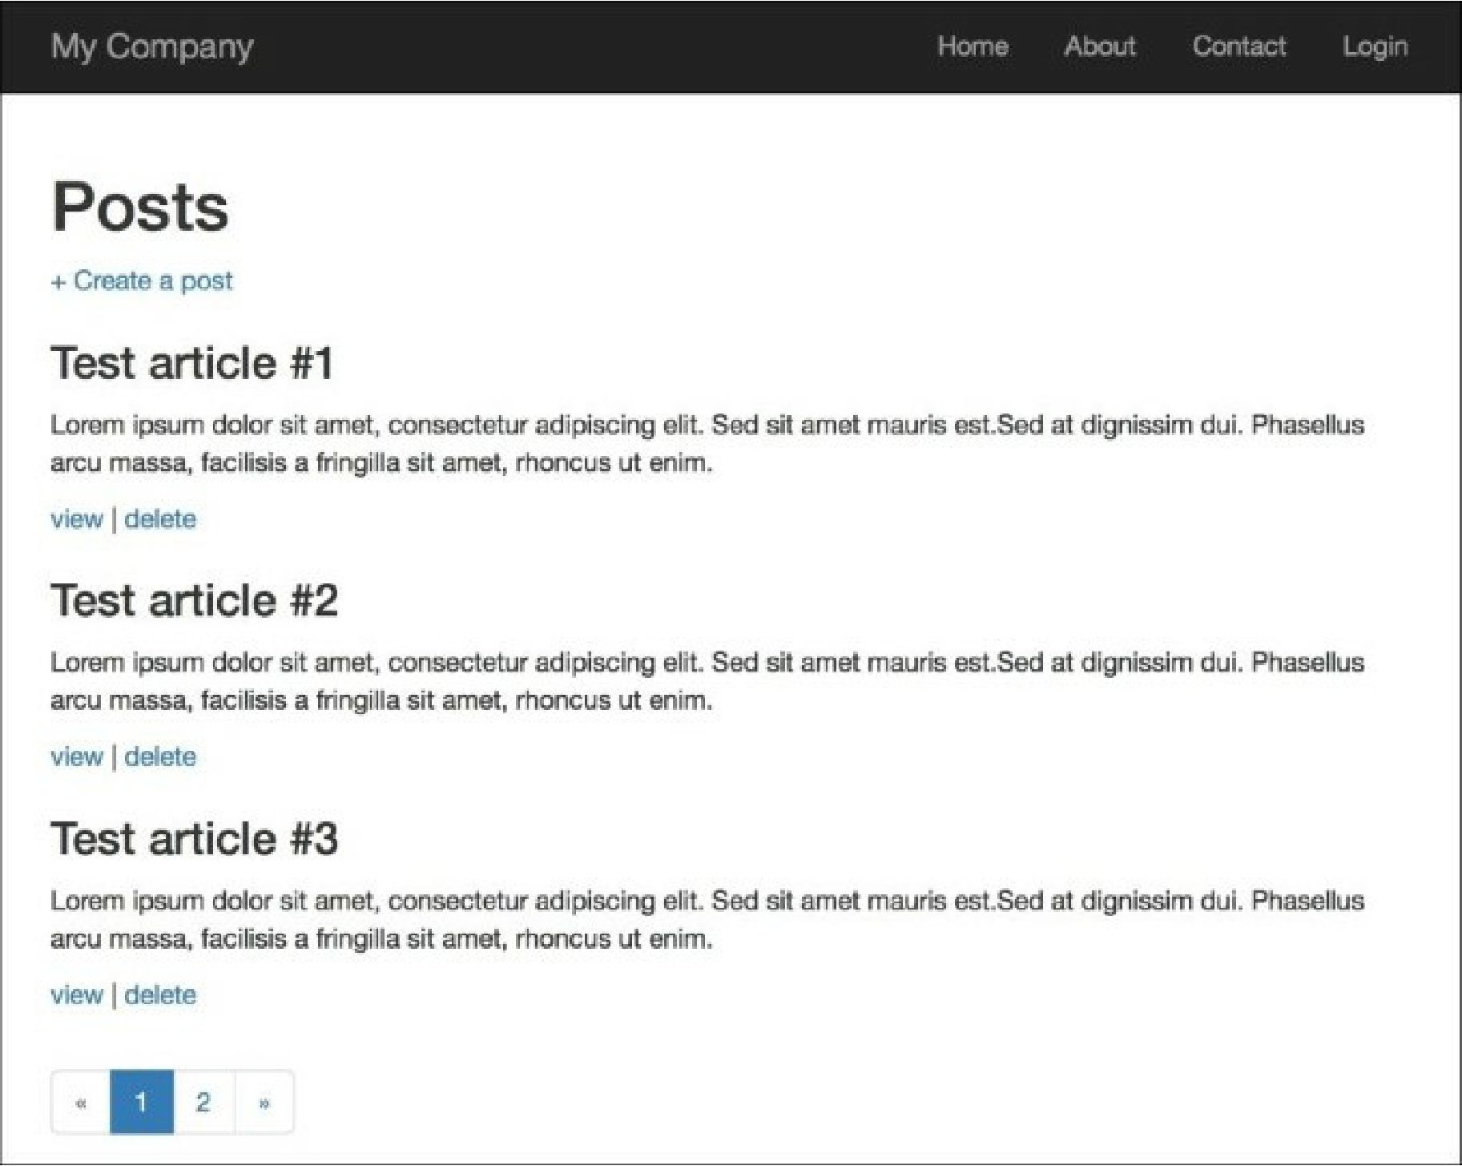

How it works...

Every controller can be built from standalone actions, like a puzzle from pieces. The difference is that you can make standalone actions very flexible and reuse them in many places.